**Sales Store Dashboard Report**

**Name: Karmveer Singh Gurjar**

**Domain: Data Science/ Data Analyst**

**Executive Summary**

In the latest analysis period, the business generated $2.3 million in total sales and achieved a profit of $282,900 with an average shipping time of 4 days. A total of 36,750 units were sold across all regions. The sales performance is strong, with significant contributions from both regional sales leaders and key customers. However, there are opportunities to further improve profitability and operational efficiency.

**Key Performance Indicators**

|  |  |
| --- | --- |
| **Metric** | **Total Sales** |
| Total Sales | 2.3 M |
| Total Profit | 282.9k |
| Profit Margin | 12.3% |
| Total Quantity | 367.5K |
| Average Shipping Days | 4days |

**Total Sales by Category**

This horizontal bar chart compares total sales across three main product categories:

* **Technology,** Furniture, and Office Supplies. Technology leads with about 836.15K in sales. This shows strong market demand and possibly higher price points or sales volume.
* **Furniture** follows with 742.00K, indicating that it is also a key revenue driver, though slightly behind Technology.
* **Office Supplies** is at 719.05K, making it the smallest contributor among the three, but it still represents a significant revenue segment.

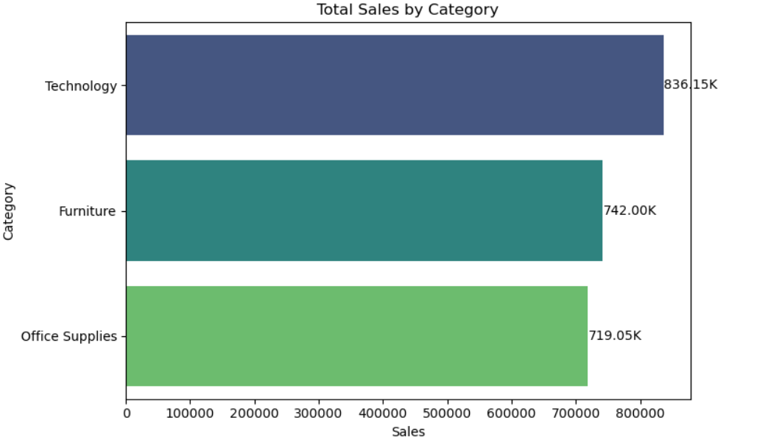

**Total Sales by Sub-Category**

This chart shows the five top sub-categories for sales:

* Phones lead just a bit with **330.01K** in total sales. Chairs come in closely behind at **328.45K**, which shows that both technology and furniture have strong revenue streams.
* Storage follows with **223.84K**, reflecting steady demand for organizational products.
* Tables and Binders generate **206.97K** and **203.41K**, respectively. This indicates moderate but meaningful contributions.

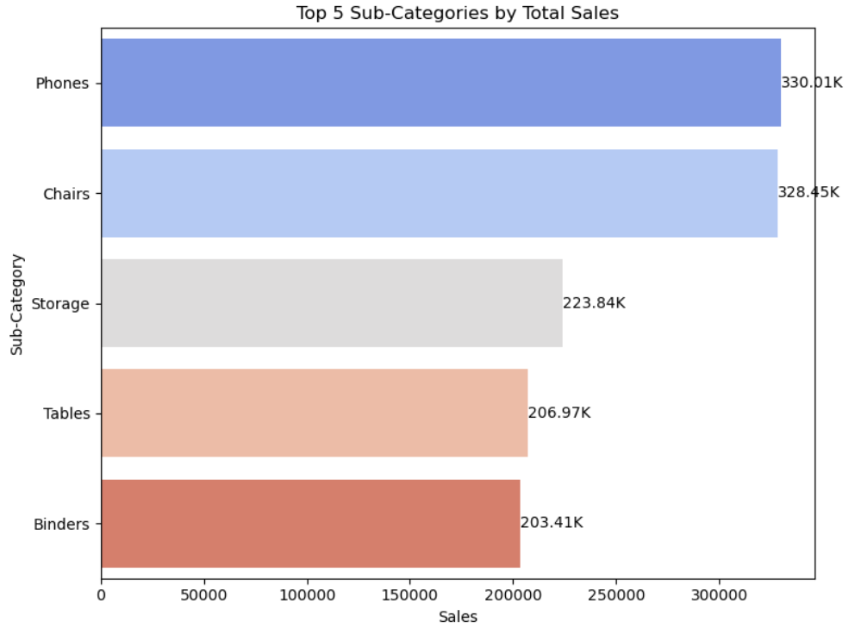

**Total Sales by Ship Mode**

This chart compares total sales generated across four shipping modes:

* Standard Class dominates with 1.36M in sales, making it the preferred shipping option for customers.
* Second Class follows with 459.19K, showing a moderate level of use.
* First Class accounts for 351.43K, indicating that a smaller portion of customers choose faster premium delivery.
* Same Day shipping has the lowest sales at 128.36K, reflecting its limited use. This may be due to higher costs or restricted availability.

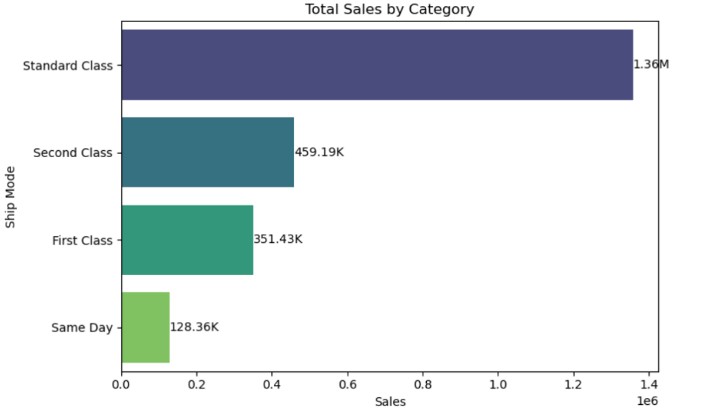

**Monthly Sales by Year**

* Sales have been increasing every year from 2014 to 2017.
* 2017 had the highest sales, especially in November and December — probably because of holiday shopping and big promotions.
* 2016 grew steadily, 2015 was stable but lower, and 2014 started low but improved by the end of the year.
* The biggest sales jumps happen at the end of the year, so focusing marketing and promotions in the last quarter could bring the best results.

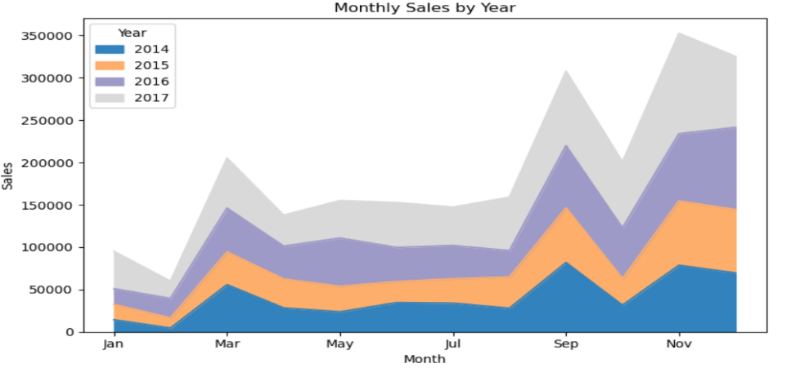

**Monthly Profit by Year**

* Profits increased every year from 2014 to 2017.
* 2017 made the most profit, especially in March, September, and December.
* 2016 grew steadily, with its biggest jump in December.
* 2015 had smaller profits but still saw good months in March, September, and November.
* 2014 started low but improved by the end of the year, with the best months in November and December.

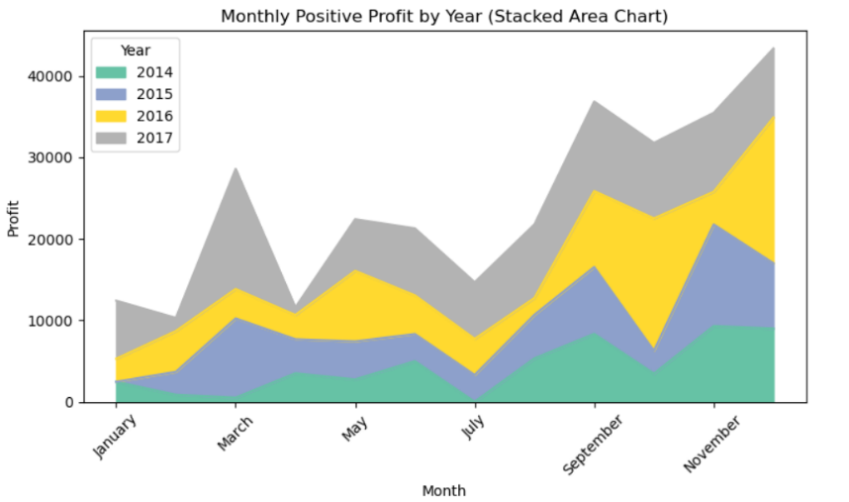

**Total Sales by Region**

This chart shows the percentage of total sales by region:

* West: Highest sales share at 31.6%.
* East: Close second with 29.5%.
* Central: Accounts for 21.8%.
* South: Lowest sales share at 17.1%.

Summary: Sales are strongest in the West and East, while the South lags behind the other regions.

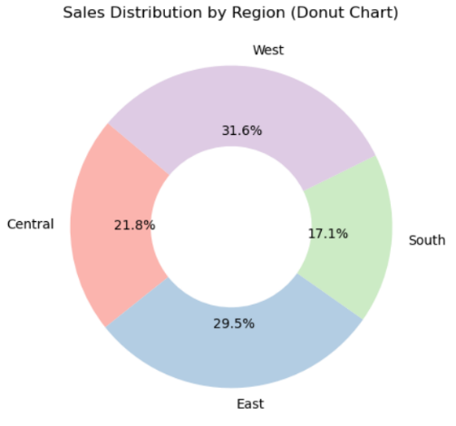

**Total Sales by Segment:**

* **Consumer**: Largest segment, making up **50.6%** of total sales.
* **Corporate**: Second-largest, with **30.7%** of sales.
* **Home Office**: Smallest segment, contributing **18.7%** of sales.

**Summary:** Most sales come from the **Consumer** segment, followed by **Corporate**, while **Home Office** is the least contributing segment.

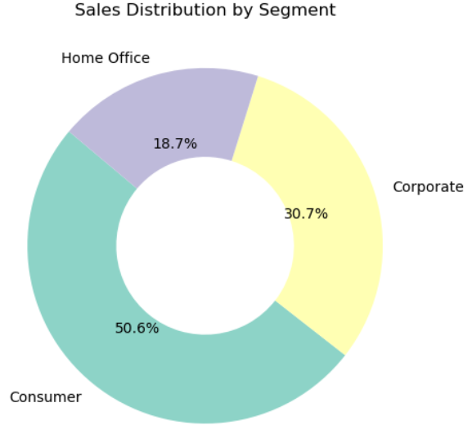

**Recommendations**

1. Expand in underperforming regions, focusing on the South.

2. Strengthen relationships with top customers.

3. Conduct a detailed profitability analysis.

4. Reduce shipping times for key accounts.

5. Diversify the customer base to lower dependency risks.

**Conclusion**

The company shows healthy sales growth and a solid profit margin of 12.3%. The West and East regions dominate revenue. However, focusing on customer diversification, regional expansion, and improving operations can increase profitability and lower business risks.